**Practical No. 8**

**Aim:** Perform vSphere Monitoring and Performance

1. **Monitoring Guest Operating System Performance.**

**Login the VMWare vSphere**

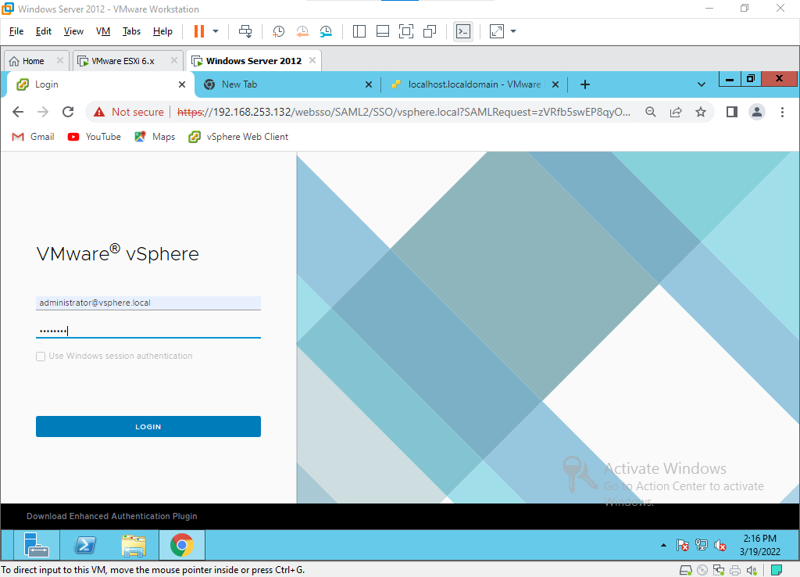

Select **Host IP address** then Click the **Monitor** tab & Click **Overview** under the Performance section.

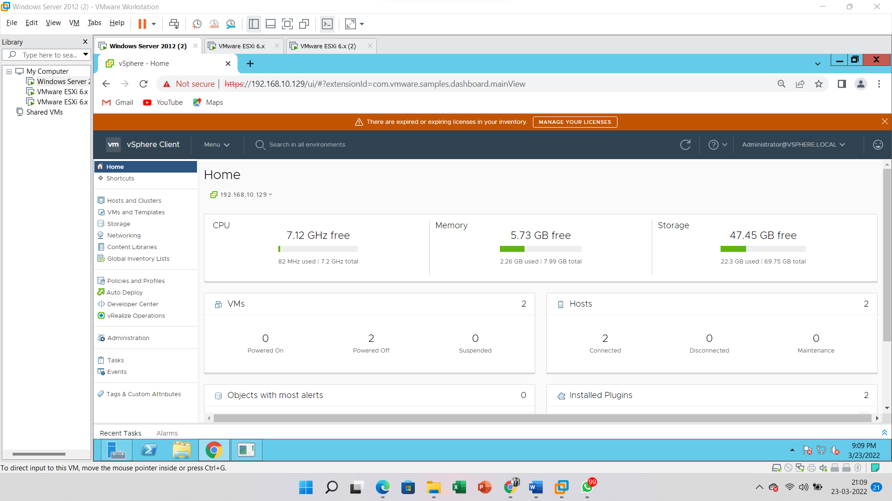

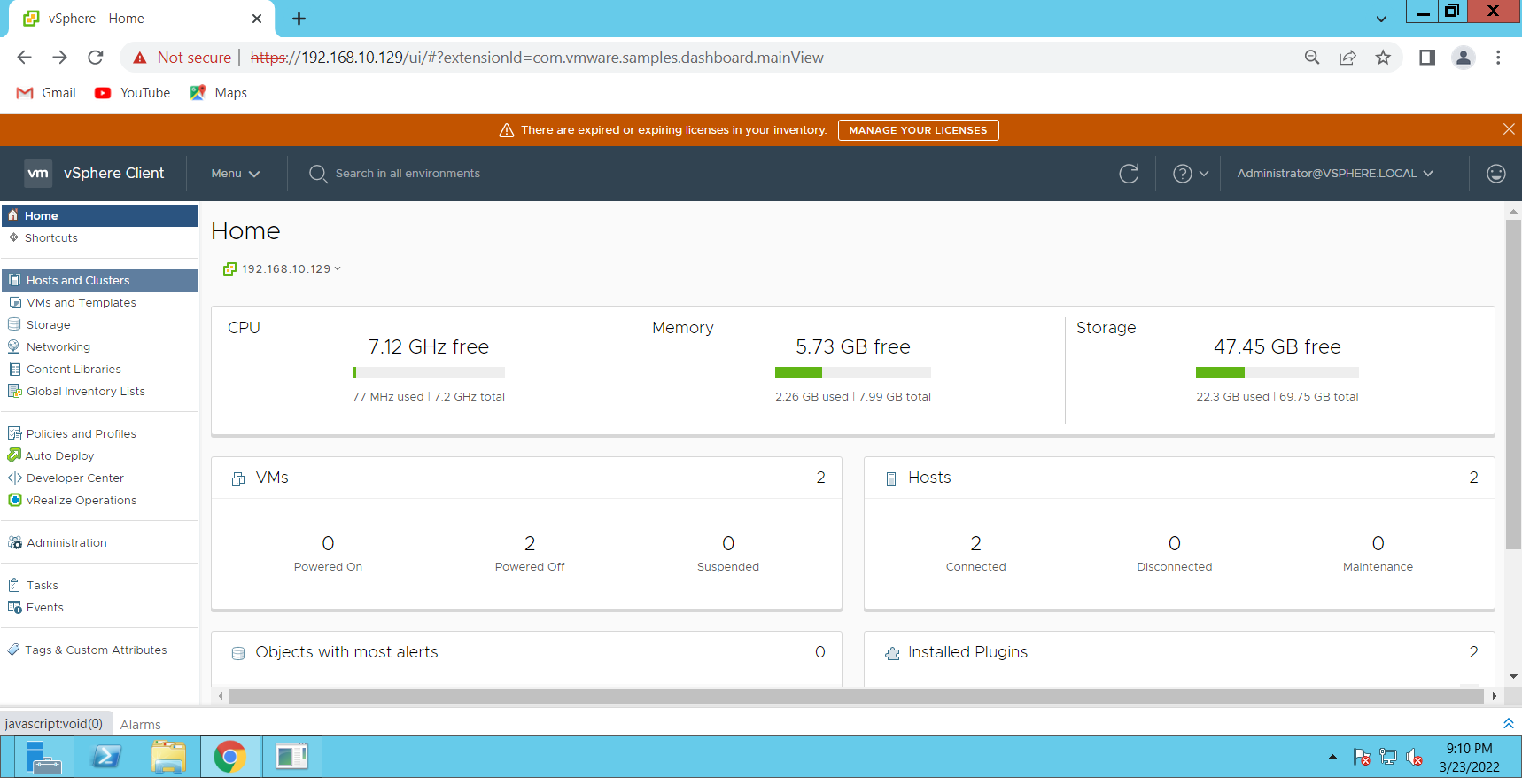

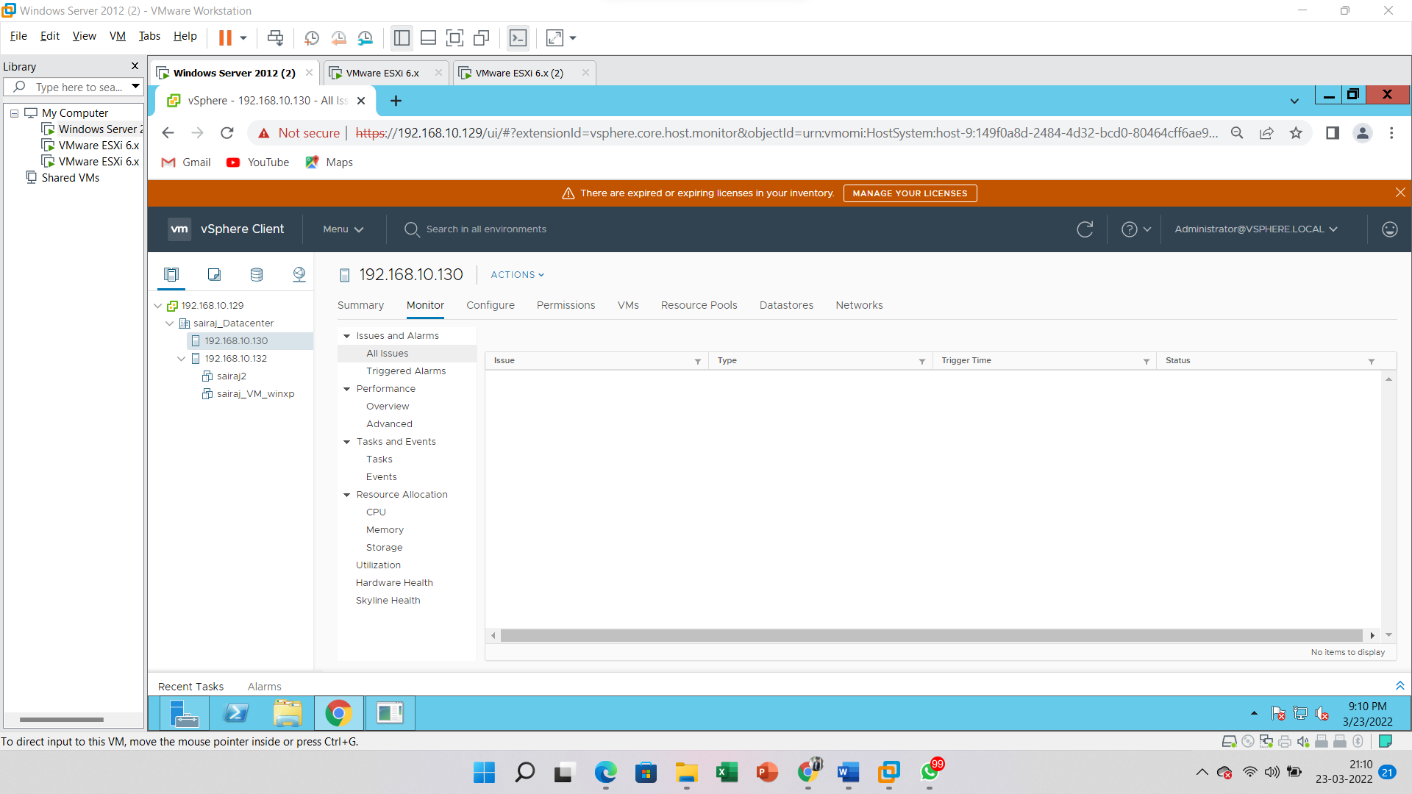

Ensure Real-time has been selected from the Time Range drop-down menu. Here we can see in real-time the CPU usage in percent for **HOST IP address**. By default, the chart will refresh every 20 seconds.

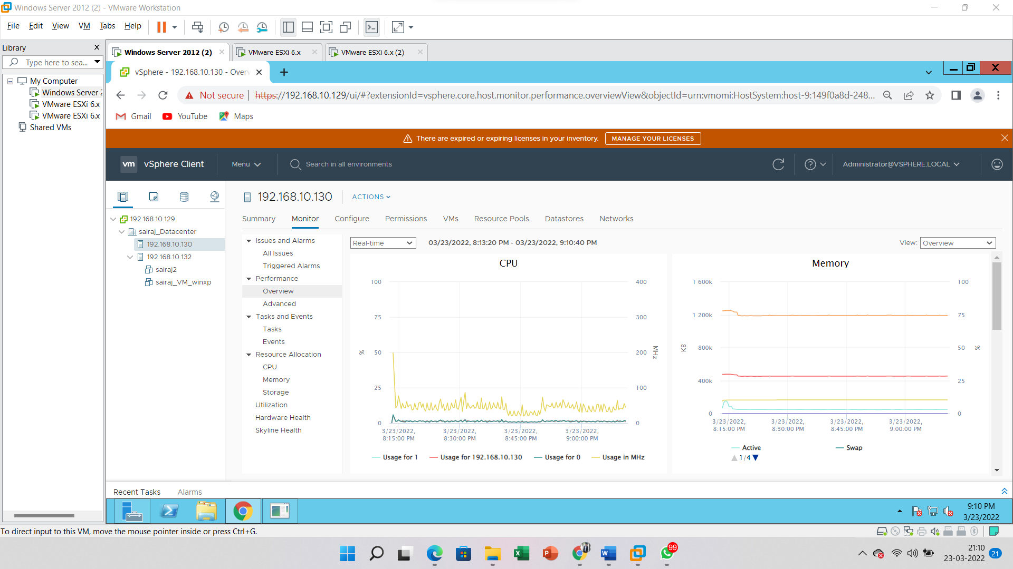

Now click the View drop-down box and select **Virtual Machines**.

This chart shows the real-time CPU usage of each virtual machine. Each VM is represented by a different color in the graph and you can see at the bottom, which VM is represented by what color. Combined, they give you an idea of overall CPU usage on the host.

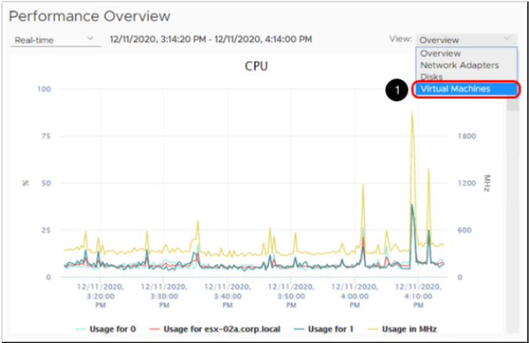There are other graphs available to show host and virtual machine memory usage, network (Mbps), and disk (KBps). Use the scroll bars to access the additional charts

The graphs we have looked at so far will give you an overview of the four main components, CPU, memory, disk, and storage. The advanced graphs will give you more detailed information on each of these.

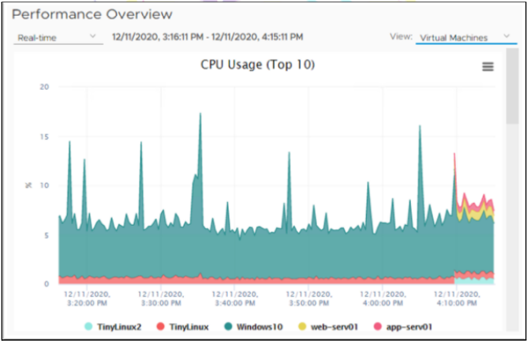

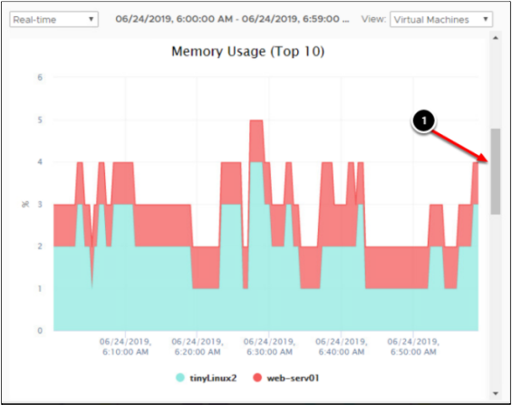

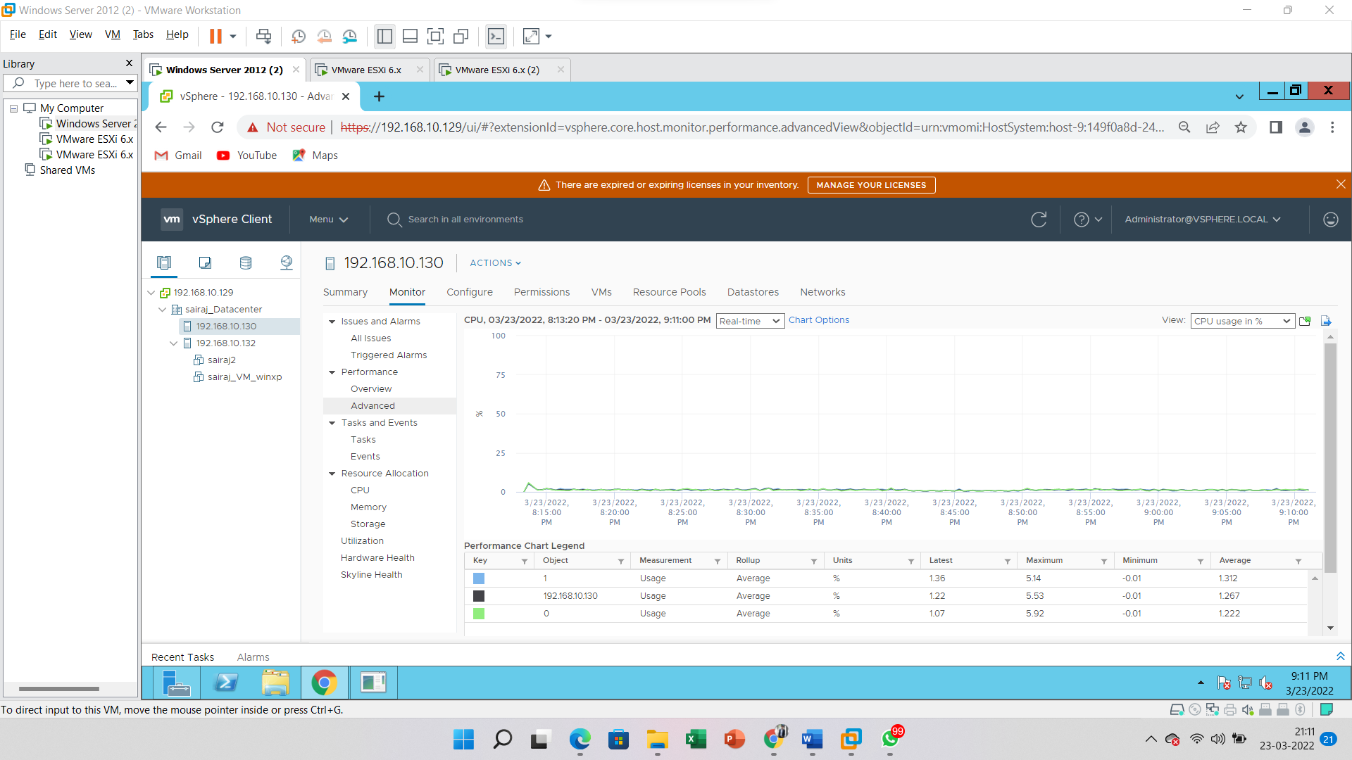

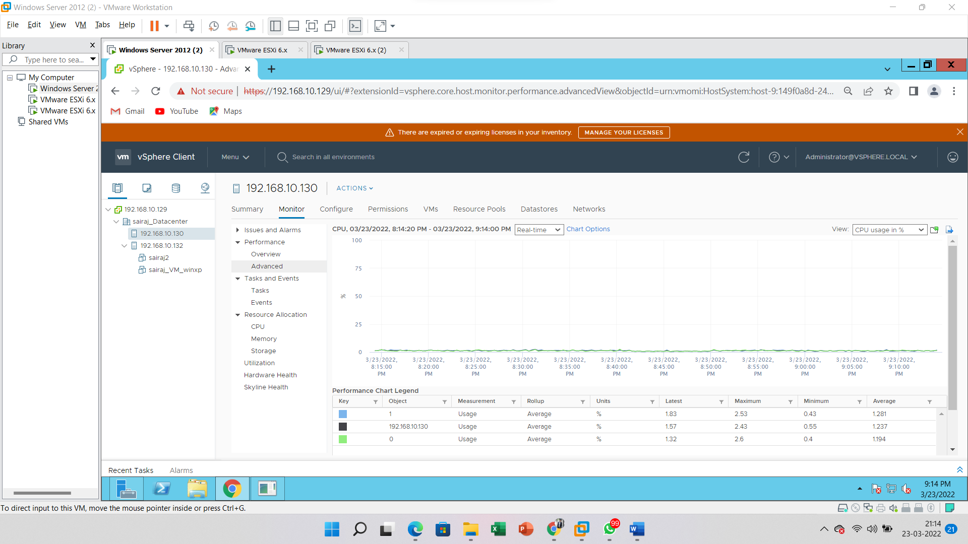

Click the Chart Options link. This will bring up options to **customize the chart.**

From the Chart Type drop-down menu, select **Stacked Graph** per VM.

Under the Select objects for this chart box, **verify all the virtual machines** are **selected**. Click the **OK** button to see the newly customized chart.

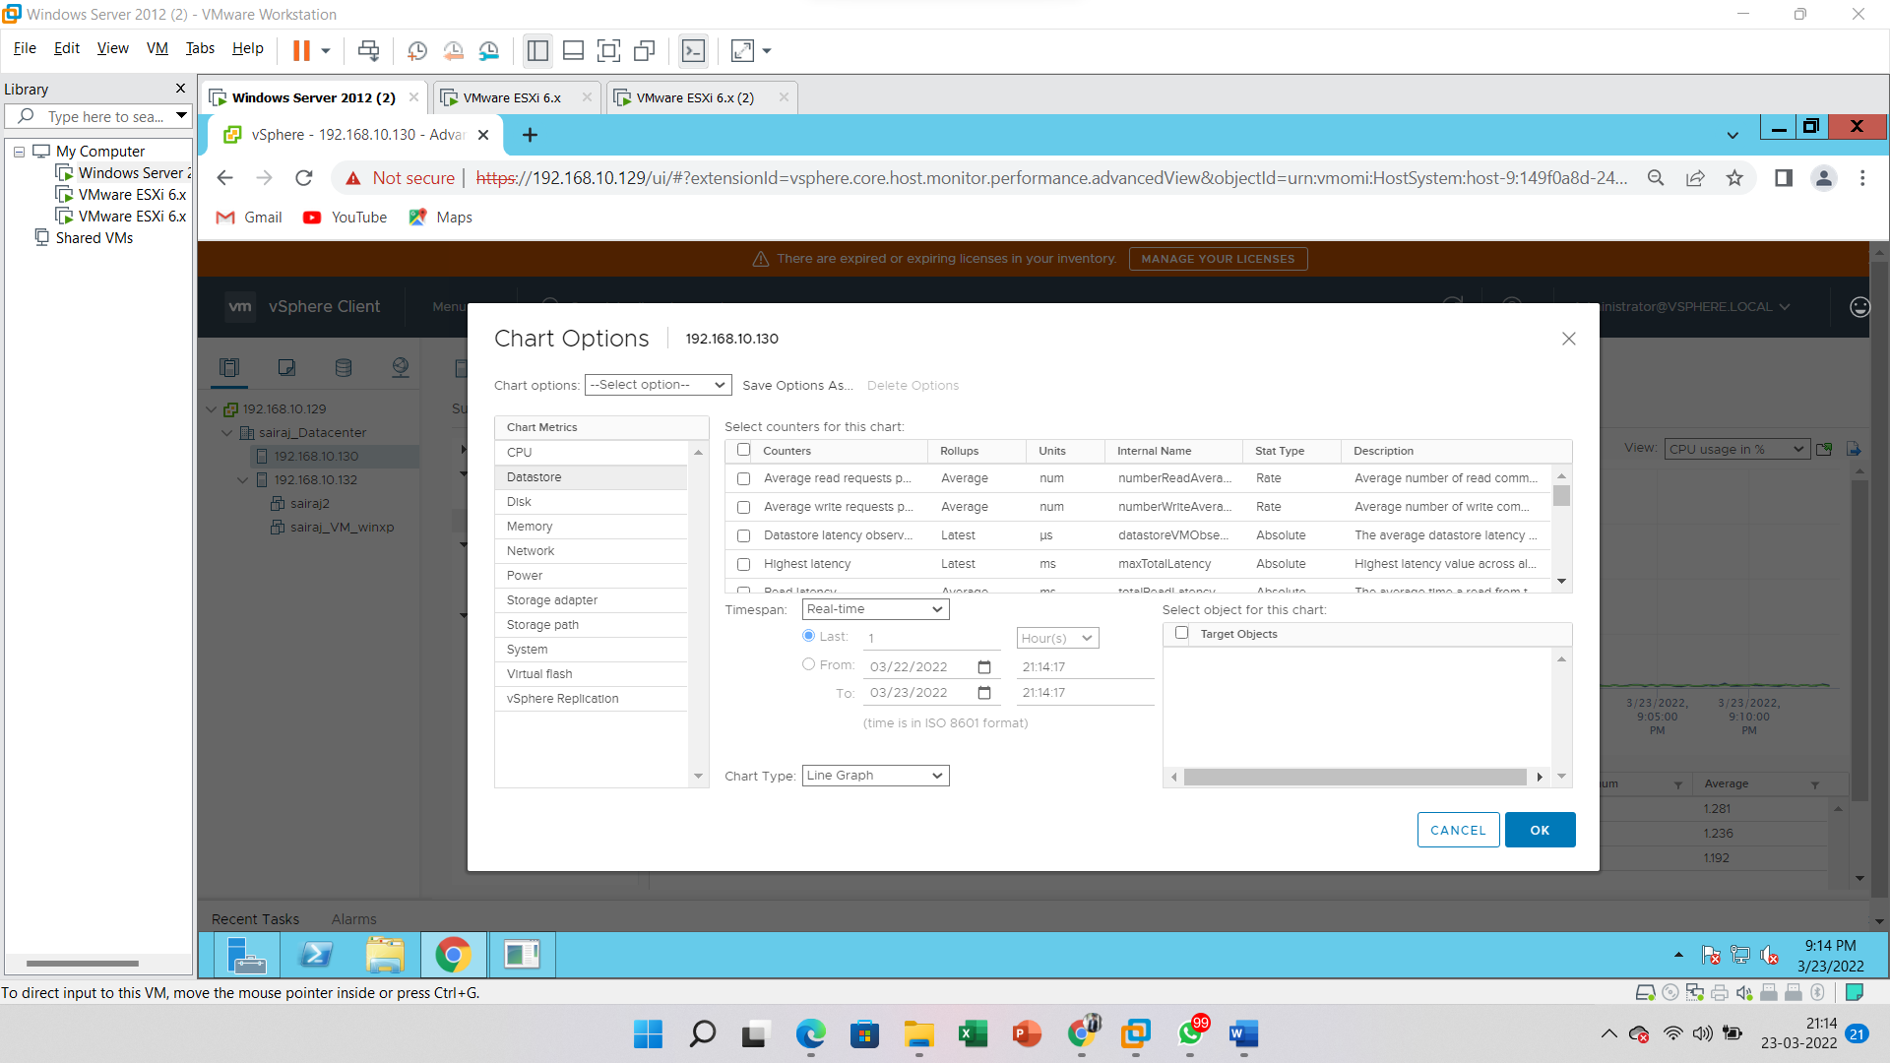

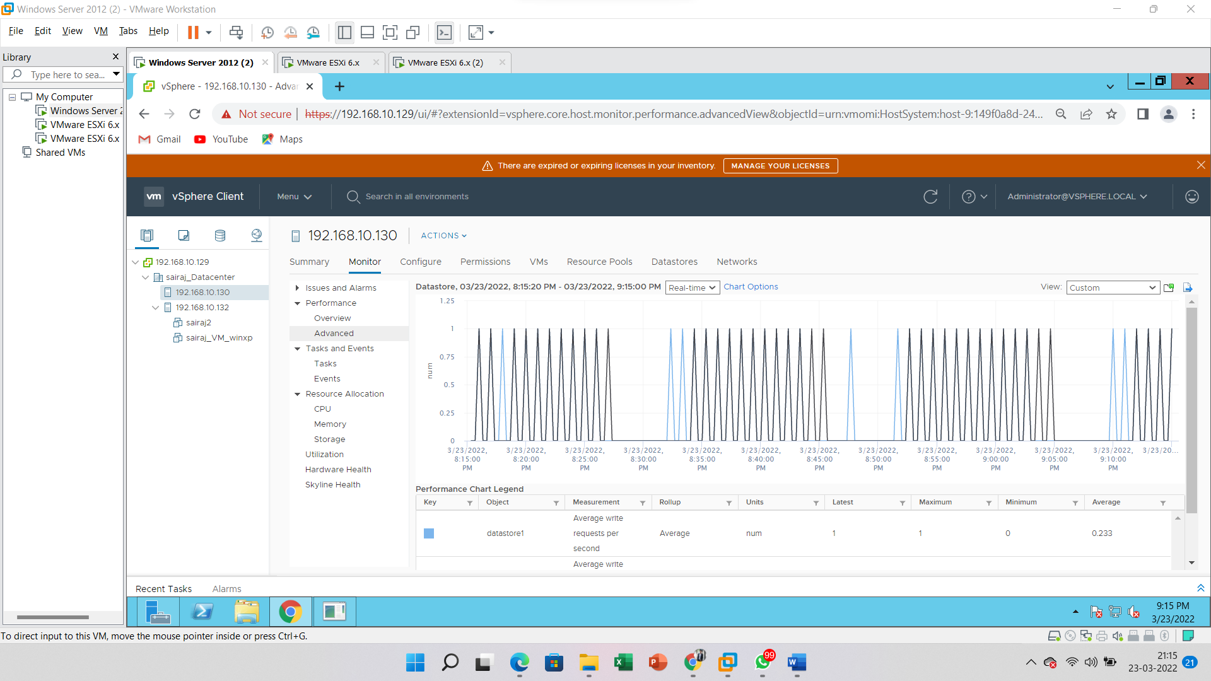

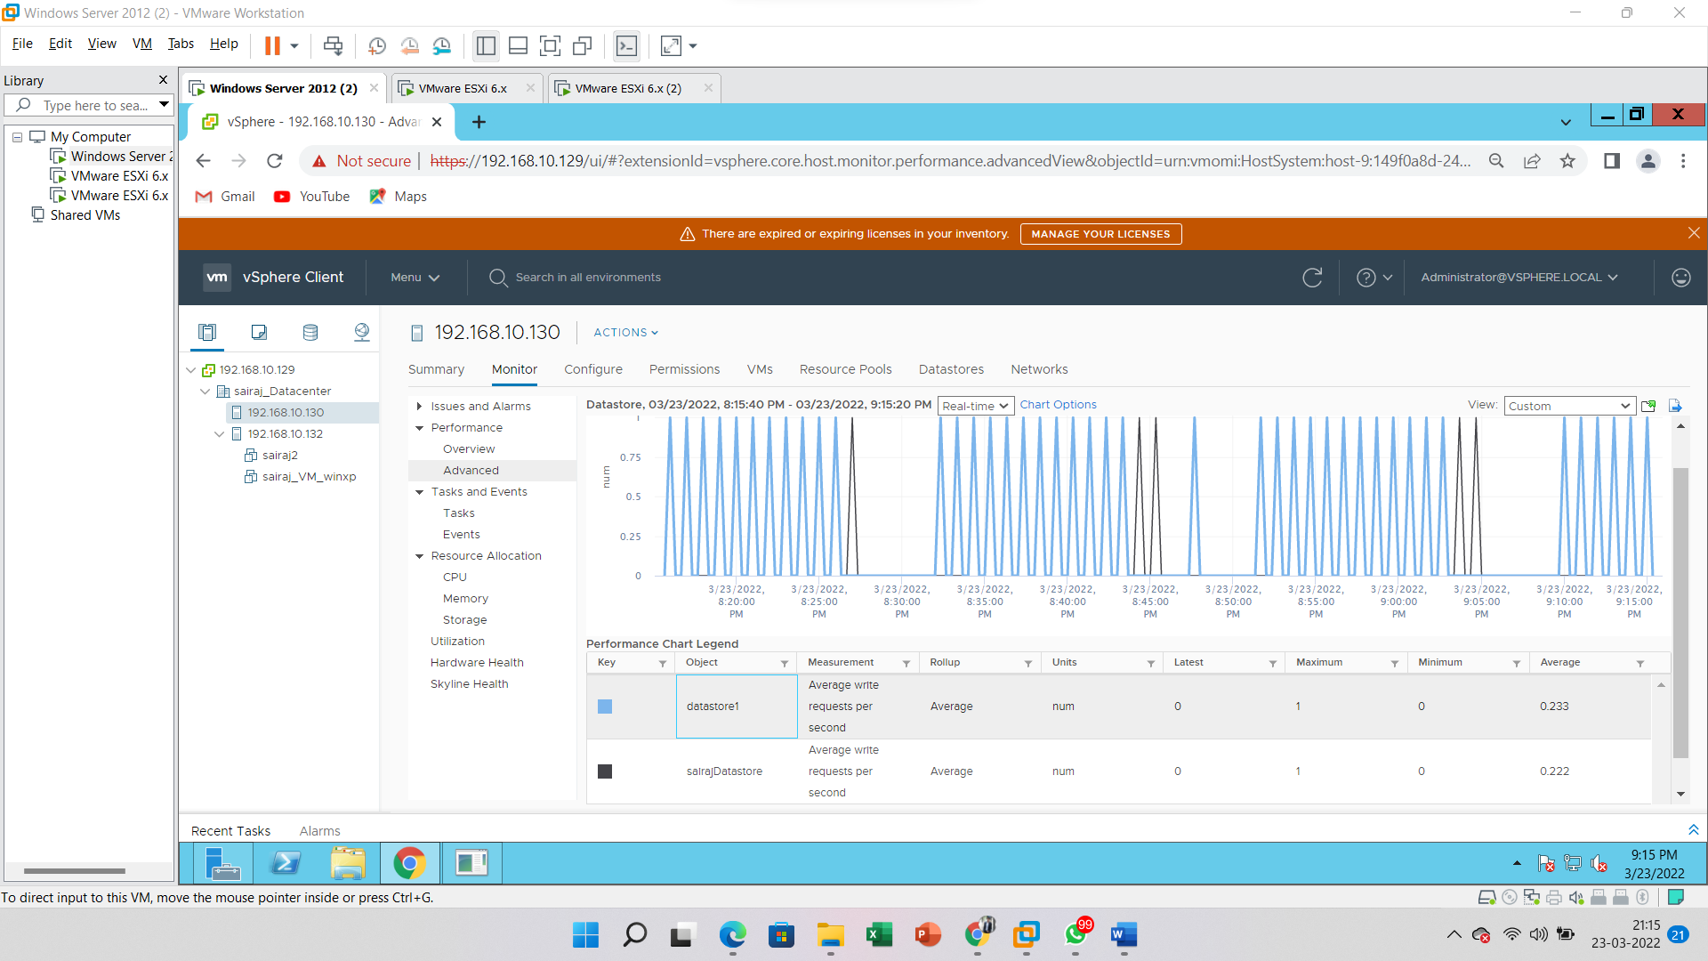

**B -Monitoring Guest Operating System Performance & View Performance Statistics for Windows Guest Operating Systems.**

For this, we need a virtual machine in running status. Let’s install the virtual machine (Windows XP).



